**Thermal Design**

Since none of the components in the converter are ideal, all of them dissipate certain amount of heat. It is essential to calculate heat dissipation of these components and provide cooling in order to achieve a stable operating temperature without harming any of the components.

In this forward converter design, only the heating of semiconductors (MOSFET and diodes) will be considered since they are the main source of heating. Rest of the components are assumed to dissipate the heat without any cooling. For equations in this part, mainly Infineon Forward Converter Design Note [x] was used as a guide.

1. MOSFET:

MOSFET has conduction losses when it is on, which is calculated with the equation x. Lowest value of 24V for input voltage was chosen, as well as rated output power, which are the worst cases for the thermal design. IDS is the average current passing through MOSFET, which was found from simulations. RDS=0.18Ω from the datasheet.

(x)

For Vi=24V and D=0.467

IDS=2.74A and PC=1.351 W

Secondly, MOSFET also has switching losses.

Switching losses are found using equations (x) and (x) where ton and toff are given in the datasheet. Assuming average voltage and current during those intervals as half of their DC values, total switching losses can be approximated.

(x)

Similarly, for turn off period,

(x)

Therefore, total power dissipation of MOSFET is

PMOSFET =1.555W

Using Lamped Parameter Model, required heatsink thermal resistivity can be found using formula (x).

(2)

Maximum operation junction temperature of MOSFET is given as 150 °C, for the design, junction temperature will be chosen as 120 °C. Ambient temperature is assumed to be 30 °C. Junction to case thermal resistivity of the MOSFET is given as 3.13 °C/W in the datasheet. Substituting these values, required heatsink thermal resistivity can be calculated as

54.75 °C/W

Also, package type should be same with the MOSFET, which is TO-220 package.

Chosen heatsink: (from digikey)

V5629G

Rth=40.00°C/W

TO-220F package (25x12x6.5 mm)

Price: $0.68

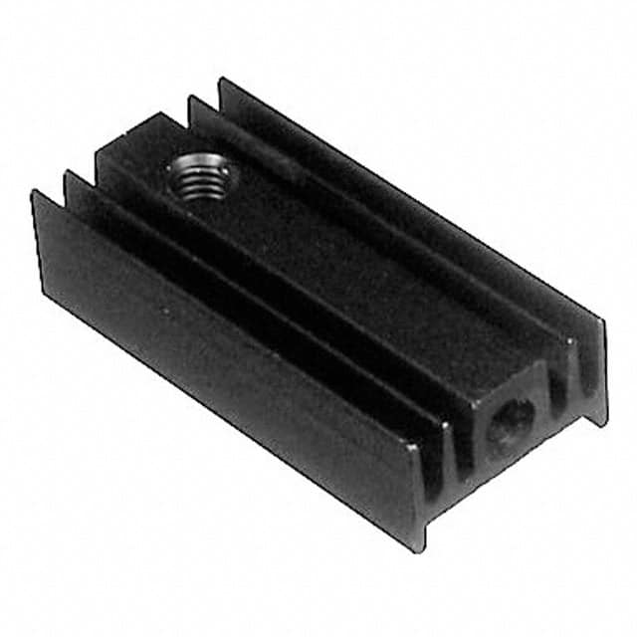

Figure X: Heatsink chosen for MOSFET(V5629G)

New junction operating temperature can be calculated with same assumed temperature values and with the chosen heatsink as follows:

1. Reset Diode:

Magnetizing inductance of the transformer discharges through this diode. Maximum average current passes through diode happens at highest D value, and from simulations it is observed as

. Maximum power loss happens at this current value, which is

VF=0.79V from datasheet. Therefore, power loss is

Switching losses for this diode is very small and can be neglected.

With temperature assumptions similar to the MOSFET analysis, same equation(x) can be used to calculated required heatsink. Junction to case thermal resistivity is 2.5 °C/W (taken from the datasheet).

Chosen heatsink: (from digikey)

V5274B-T

Package: TO-220 (same with the diode) 25x12x4.5mm

Rth=60.00°C/W

Price: $0.55



Figure X: Heatsink chosen for reset diode(V5274B-T)

This heatsink was chosen because it had the highest thermal resistivity with this package type. Junction temperature can be recalculated with same assumptions as follows:

1. Secondary diodes:

2 secondary diodes carry current equal to output current, one in D and other one in 1-D period. They were chosen as a single package 3 leg diode. They will both be cooled with the same heatsink. As the duty cycle changes, one will dissipate more while the other one will less. Since they are on the same chip, it can be approximated that it has a constant current flow equal to output current, and voltage drop of 0.79V given in datasheet. Assuming rated output power, Iout=4.8A. Therefore, conduction losses will be simply,

Switching losses are very small and will be neglected.

With similar steps as before, required heatsink thermal resistivity can be calculated as:

(2)

21.19 °C/W

Chosen heatsink: (from digikey)

HSE-B1711-032

Rth= 20.27°C/W

TO-220 package (25x16x9 mm)

Price: $0.27550

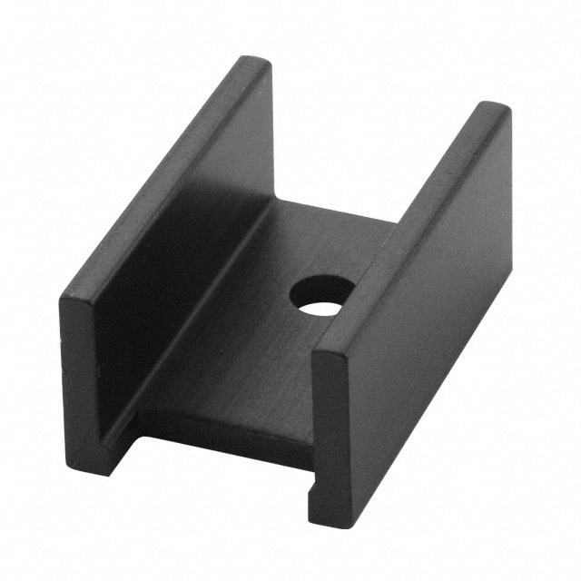

Figure X: Heatsink chosen for secondary diodes(HSE-B1711-032)